

BANKING CONSULTANCY

Software Requirement Specification

Project Code: PCBC001
Document Code: SRS_BC – v0.1

HCM City, 15/01/2013

Record of change

*A - Added M - Modified D - Deleted
Effective Date | Changed Items | A*  M, D | Change Description | New Version
15/01/2013 | Initial | A | Add Introduction | 0.1
24/02/2013 | Overall Description | A | Add overall description, 3 functions | 0.2
28/02/2013 | Functional, non-functional | A,D | Add non-functions, add more 2 functions, add sequence diagram | 0.2

SIGNATURE PAGE

ORIGINATOR: Nguyễn Phan Anh 15/01/2013
Lê Phước Việt
Nguyễn Anh Tuấn
Đường Huy Hoàng
Võ Công Đoàn
REVIEWERS: Lâm Hữu Khánh Phương <Date>

APPROVAL: Lâm Hữu Khánh Phương <Date>

TABLE OF CONTENTS
1 Introduction 5
1.1 Purpose 5
1.2 Scope 5
1.3 Definitions, Acronyms, and Abbreviations 5
1.4 References 6
1.5 Overview 6
2 Overall Description 8
2.1 Product perspective 8
2.2 Product functions 8
2.3 User characteristics 8
2.4 Constraints 8
2.5 Assumptions and dependencies 8
2.6 Requirements subsets 8
3 FUNCTIONAL Requirements 9
3.1 Update database 9
3.2 View information and calculate money 9
3.3 View top highest interest rate banks 11
3.4 Calculate interest rate 11
4 Uscase model 12
4.1 <Use Cases Diagram> 12
4.2 <Use Cases’ Details> 12
4.3 <Functional Requirement one> 12
5 NON-FUNCTIONAL Requirements 15
5.1 Usability 15
5.2 Reliability 15
5.3 Performance 16
5.4 Supportability 16
5.5 Design Constraints 16
5.6 On-line User Documentation and Help System Requirements 16
5.7 Purchased Components 17
5.8 Interfaces 17
5.9 Licensing Requirements 17
5.10 Legal, Copyright, and Other Notices 17
5.11 Applicable Standards 17
6 Supporting Information 19

Introduction

Purpose
This document formally describes the software requirement specification of the Banking Consultancy. It will explain the purpose and features of the system, the interfaces of the system, and what the system will do, also describe non-functional requirements, design constraints.

Scope
The software includes 3 main parts.
- The homepage website: This website will collect the information of all banks in a specify area (example in Vietnam). The website shows the list of all banks which are collected. The website has a link for user to download the Client Program (CP) to install on user mobile.
- The web service: this web is invisible with the user. It’s a bridge between homepage website and the CP. The CP will get the information from homepage website through this web service.
- The Client Program: This is the program will be installed on user mobile. The CP requires android OS. The user will interact almost with this software by the CP. The CP will get information of banks from web service and help the user work out the interests, estimate the time which the user need to wait to have their wanted money, list the top 10 banks have the highest interest to help the user easily choose the best bank.

Definitions, Acronyms, and Abbreviations
Definitions
Client Program | This is a module of software. It will be installed on the user mobile. This module requires the mobile run on Android OS.
Abbreviations
URD | User Requirements Document
OS | Operating System
GUI | Graphic User Interface
CP | Client Program

References
- http://en.wikipedia.org/wiki/
- URD Template on http://cms-hcm.fpt.edu.vn

Overview
This SRS contains 6 sections:
- Section 1 – Introduction: This section introduce generally about this document and this software. It includes purpose of SRS; the scope of software; definitions, acronyms and abbreviations in SRS; list of all reference document or website; and the overview to list all sections in this SRS.
- Section 2 – Overall Description: It includes product perspective, product functions, user characteristics, constraints, assumptions and dependencies, requirements subsets. This section describes the general factors that affect the product and its requirements. This section does not state specific requirements. Instead, it provides a background for those requirements, which are defined in detail in next section, and makes them easier to understand.
- Section 3 – Functional requirements: This section describes detail of all software’s functions. There are 3 main functions and an extra function. In the main function Calculate, there are 2 options for user: calculate the money and range time.
- Section 4 – Use case model: This section represents the use case diagram of the software. It includes the Actors that interact with the system and the Use Cases that describe these interactions.
- Section 5 – Non – functional requirements: This section describes the non-functional requirements of the system. It includes usability, reliability, performance, supportability, etc.
- Section 6 – Supporting information: This section describes the supporting information to make the SRS easier to use. It includes an interface diagram. It makes users easier to view the relative interfaces.

Overall Description

Product perspective
User can use all function supported by software to get information about banks with related information such as interest, contact information… Besides, software use these information to automatically give users advices that help them to choose appropriate bank.

Product functions
The software includes main functions below:
- Update database: use internet connection to connection to server to update database.
- View information and calculate money:
  - View information: provide all of related information about the bank.
  - Calculate money: calculate sum of money that depositor will receive from input

User characteristics
- Casual user: the normal users who have not much knowledge of Android device.
- Power user: the users that have a lot of experience about using Android device.

Constraints
Run on Android 2.2 device, internet connection (for updating database).

Assumptions and dependencies

Requirements subsets

FUNCTIONAL Requirements

Update database
This function supports users for update information from server in order to make sure information is always up to date.
This function will check the internet connection or not. If device can connection to server, it get version in database and send it through internet to server. The server is responsible for compare version on server with version in database, if they are same, return true, or not, return false and update database that stored in device again.
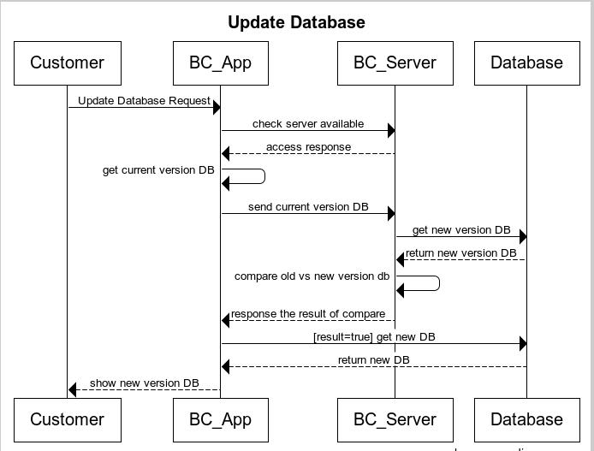
Figture 1 - Update Database Sequence diagram

View information and calculate money
This function provide all of related information of banks in list and support users calculate sum of money that depositor will receive from input.
The users choose one bank in list, and there’re 2 sub-function below:
View information: provide all of related information of bank in list: short name, full name, address, phone, fax, homepage, description (optional).
Calculate money: the uses will choose interest (annual rate – load from database), deposit. The software bases on these input and calculate sum of money that depositor will receive
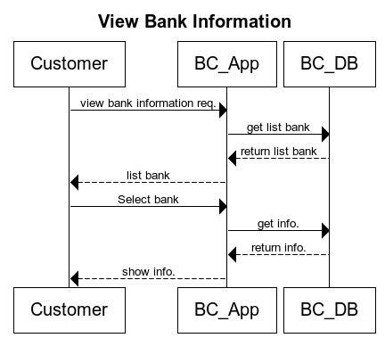
Figure 2 - View Bank Sequence Diagram
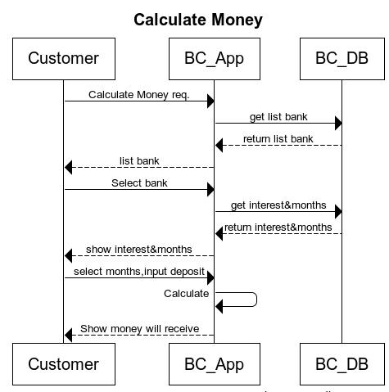
Figure 3 - Calculate Money Sequence Diagram

View top highest interest rate banks
This function provide top 10 banks that have highest interest rate to help the user easy to choose the suitable bank.
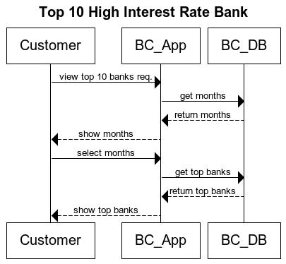
Figure 1 - Top 10 high rate interest Bank

Calculate interest rate
This function help the user calculate the interest rate least to have the money will receive after number of months. The user input the deposit and the money will receive, and number of months, the application will calculate and show to user the least interest rate that user need.
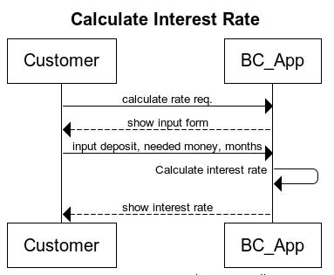
Figure 5 - Calculate Interest Rate Sequence Diagram

Uscase model
[The Use Case Model defines the behavior of the system (functional specification) from the users’ perspective. It includes the Actors that interact with the system and the Use Cases that describe these interactions.]

<Use Cases Diagram>
[The main Use Case Diagrams of the system]

<Use Cases’ Details>

<Functional Requirement one>

<Use Case Name 1>
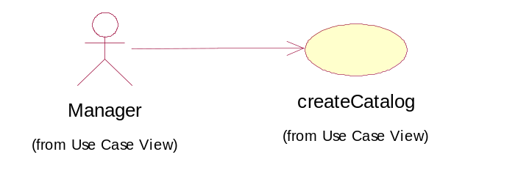
User Case ID | UC_1.1
Name | Use Case Name 1
Goal | Want to create a Catalog
Actors | Manager
Pre-conditions | User must log in with role “Manager”
Post-conditions
Main Flow | 1. Create a skill category.  3. Enter skill category information: Name, Note.  5. Display “Complete!” message. | 2. Display Create skill category form and request to enter skill category information.  4. Validate skill category information.
Exception | 1A: if role is not correct, show error message and ask to log in again.  4A: if skill category information is not correct, show error message and ask to input again.
Open Issues | N/A

Example:
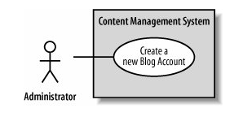
Use case name | Create a new Blog Account
Related Requirements | Requirement A.1.
Goal In Context | A new or existing author requests a new blog account from the Administrator.
Preconditions | The system is limited to recognized authors and so the author needs to have appropriate proof of identity.
Successful End Condition | A new blog account is created for the author.
Failed End Condition | The application for a new blog account is rejected.
Primary Actors | Administrator.
 | Secondary Actors | Author Credentials Database.
 | Trigger | The Administrator asks the CMS to create a new blog account.
Main Flow | Step | Action
 | 1 | The Administrator asks the system to create a new blog account.
 | 2 | The Administrator selects an account type.
 | 3 | The Administrator enters the author's details.
 | 4 | The author's details are verified using the Author Credentials Database.
 | 5 | The new blog account is created.
 | 6 | A summary of the new blog account's details are emailed to the author.
Extensions | Step | Branching Action
 | 4.1 | The Author Credentials Database does not verify the author's details.
 | 4.2 | The author's new blog account application is rejected.

<Use Case Name 2>
…………………

NON-FUNCTIONAL Requirements
[This section describes the non-functional requirements of the system. Some examples are listed as below]

Usability
[This section includes all those requirements that affect usability. For example,
specify the required training time for a normal users and a power user to become productive at particular operations
specify measurable task times for typical tasks or base the new system’s usability requirements on other systems that the users know and like
specify requirement to conform to common usability standards, such as IBM’s CUA standards Microsoft’s GUI standards]
<Usability Requirement One>
[The requirement description goes here.]

Reliability
[Requirements for reliability of the system should be specified here. Some suggestions follow:
Availability—specify the percentage of time available ( xx.xx%), hours of use, maintenance access, degraded mode operations, and so on.
Mean Time Between Failures (MTBF) — this is usually specified in hours, but it could also be specified in terms of days, months or years.
Mean Time To Repair (MTTR)—how long is the system allowed to be out of operation after it has failed?
Accuracy—specifies precision (resolution) and accuracy (by some known standard) that is required in the system’s output.
Maximum Bugs or Defect Rate—usually expressed in terms of bugs per thousand lines of code (bugs/KLOC) or bugs per function-point( bugs/function-point).
Bugs or Defect Rate—categorized in terms of minor, significant, and critical bugs: the requirement(s) must define what is meant by a “critical” bug; for example, complete loss of data or a complete inability to use certain parts of the system’s functionality.]
<Reliability Requirement One>
[The requirement description.]

Performance
[The system’s performance characteristics are outlined in this section. Include specific response times. Where applicable, reference related Use Cases by name.
Response time for a transaction (average, maximum)
Throughput, for example, transactions per second
Capacity, for example, the number of customers or transactions the system can accommodate
Degradation modes (what is the acceptable mode of operation when the system has been degraded in some manner)
Resource utilization, such as memory, disk, communications, and so forth.
<Performance Requirement One>
[The requirement description goes here.]
Interfaces

Supportability
[This section indicates any requirements that will enhance the supportability or maintainability of the system being built, including coding standards, naming conventions, class libraries, maintenance access, and maintenance utilities.]
<Supportability Requirement One>
[The requirement description goes here.]

Design Constraints
[This section indicates any design constraints on the system being built. Design constraints represent design decisions that have been mandated and must be adhered to. Examples include software languages, software process requirements, prescribed use of developmental tools, architectural and design constraints, purchased components, class libraries, and so on.]
<Design Constraint One>
[The requirement description goes here.]

On-line User Documentation and Help System Requirements
[Describes the requirements, if any, for o-line user documentation, help systems, help about notices, and so forth.]

Purchased Components
[This section describes any purchased components to be used with the system, any applicable licensing or usage restrictions, and any associated compatibility and interoperability or interface standards.]

Interfaces
[This section defines the interfaces that must be supported by the application. It should contain adequate specificity, protocols, ports and logical addresses, and the like, so that the software can be developed and verified against the interface requirements.]
User Interfaces
[Describe the user interfaces that are to be implemented by the software.]
Hardware Interfaces
[This section defines any hardware interfaces that are to be supported by the software, including logical structure, physical addresses, expected behavior, and so on.]
Software Interfaces
[This section describes software interfaces to other components of the software system. These may be purchased components, components reused from another application or components being developed for subsystems outside of the scope of this SRS but with which this software application must interact.]
Communications Interfaces
[Describe any communications interfaces to other systems or devices such as local area networks, remote serial devices, and so forth.]

Licensing Requirements
[Defines any licensing enforcement requirements or other usage restriction requirements that are to be exhibited by the software.]

Legal, Copyright, and Other Notices
[This section describes any necessary legal disclaimers, warranties, copyright notices, patent notices, wordmark, trademark, or logo compliance issues for the software.]

Applicable Standards
[This section describes by reference any applicable standard and the specific sections of any such standards which apply to the system being described. For example, this could include legal, quality and regulatory standards, industry standards for usability, interoperability, internationalization, operating system compliance, and so forth.]

Supporting Information
[The supporting information makes the SRS easier to use. It includes:
Table of contents
Index
Appendices
These may include use-case storyboards or user-interface prototypes. When appendices are included, the SRS should explicitly state whether or not the appendices are to be considered part of the requirements.]

